MINI AGENT AI EXECUTION AND RESOURCE MANAGEMENT SYSTEM
Operating Systems and Systems Programming (25CS2104E)
Project Documentation
Submitted in partial fulfilment of the requirements for the course
OPERATING SYSTEMS AND SYSTEMS PROGRAMMING
2026–27, Term-I
DEPARTMENT OF COMPUTER SCIENCE ENGINEERING
By
Pothuru Bhavana Manswini – 2520030154
Kakrapati Rishitha - 2520030367

Team Number: 23
Section: 9
Under the Guidance of
Dr. Ms Harika Devi
Department of Computer Science and Engineering

Koneru Lakshmaiah Education Foundation (Deemed to be University)
Bachupally–Gandimaisamma Road, Bowrampet, Hyderabad, Telangana – 500 043


DEPARTMENT OF COMPUTER SCIENCE ENGINEERING
DECLARATION
We hereby declare that the project entitled “Mini Agent AI Execution and Resource Management System” is an academic project carried out as part of the requirements for the Operating Systems and Systems Programming course.
The project demonstrates, on Linux (Ubuntu), how multiple AI agents can be created, executed, coordinated, and managed as independent operating-system processes. A manager process creates agent processes with fork(), assigns tasks from a queue through pipes, monitors CPU and memory usage through /proc, collects results, and terminates all agents safely.
This documentation describes the design, implementation, testing procedure, measured results, limitations, and possible future improvements. The “agents” are simulated AI workers that execute computational tasks; the project does not use machine-learning models. All sample output and timing values in Chapter 5 were recorded from actual runs of the program on the test environment stated there.

P. Bhavana Manaswini – 2520030154
K. Rishitha – 2520030367

CERTIFICATE
This is to certify that the project entitled “Mini Agent AI Execution and Resource Management System” is a project work carried out by the students named on the cover page, under the guidance of the undersigned, as part of the academic requirements for the Operating Systems and Systems Programming course (25CS2104E).
The project focuses on Linux process management, inter-process communication, synchronization, and resource monitoring using C, GCC, and POSIX system calls on Ubuntu.

Signature of the Guide | Signature of the HOD
(Dr. ______________________)

Signature of the External Examiner

ACKNOWLEDGEMENT
We express our sincere gratitude to our course instructor and project guide for their guidance and encouragement during the development of this Operating Systems and Systems Programming project. We also thank the Department of Computer Science and Engineering and Koneru Lakshmaiah Education Foundation for giving us the opportunity to explore Linux process management, inter-process communication, and resource management through practical implementation.
We acknowledge the Linux manual pages and the GNU and Ubuntu documentation, which provided the technical foundation for understanding process creation, pipes, waiting, polling, resource limits, and the /proc file system.
Finally, we thank our team members and classmates for their discussions, feedback, and support throughout the project.

ABSTRACT
In multi-agent AI systems, several agents often execute competing tasks at the same time. Without a coordinating mechanism this leads to inefficient resource usage and poor control over how the agents run. The Mini Agent AI Execution and Resource Management System is a Linux-based project that demonstrates how multiple agents can be created, executed, coordinated, and managed as independent operating-system processes.
A central manager process maintains a task queue and creates agent processes with fork(). Tasks are assigned to idle agents over pipes (inter-process communication), and each agent returns its result to the manager through a second pipe. The manager uses poll() to wait for results, reads /proc/<pid>/stat and /proc/<pid>/status to monitor the CPU time and resident memory of every agent, applies a per-agent CPU limit with setrlimit(), and finally sends a stop message and calls waitpid() so that every agent terminates cleanly without leaving zombie processes.
The system is written in C for Ubuntu and was tested with 2, 4, and 8 agents processing 16 tasks. In every test all tasks completed, all agents terminated with status 0, and no process was left behind. The project gives hands-on experience with process management, IPC, synchronization, scheduling, and resource management.
Keywords: Operating Systems, Linux, Ubuntu, C Programming, Multi-Agent System, fork(), Pipes, IPC, Synchronization, Resource Monitoring, /proc.

TABLE OF CONTENTS
Section | Contents
Preliminary pages | Declaration, Certificate, Acknowledgement, Abstract
Chapter 1 | Introduction
Chapter 2 | System Requirements and Background
Chapter 3 | System Design
Chapter 4 | Implementation
Chapter 5 | Testing and Results
Chapter 6 | Challenges and Limitations
Chapter 7 | Conclusion and Future Work
References | Technical documentation and manuals
Appendix A | Complete source code (mini_agent.c)

LIST OF FIGURES
- Figure 3.1 — High-level architecture of the Mini Agent system
- Figure 3.2 — System workflow
- Figure 3.3 — Process tree and IPC channels
- Figure 5.1 — Average task time and total completion time versus number of agents

CHAPTER 1: INTRODUCTION

1.1 Overview
An operating system runs every program as one or more processes and decides how they share the CPU, memory, and other resources. Modern AI applications often use several cooperating software agents, each responsible for a part of a larger job. From the operating system’s point of view, each agent is simply a process that must be created, given work, observed, and eventually terminated.
This project builds a small, educational version of such a system for Ubuntu Linux. A manager process creates agent processes, distributes tasks to them, collects their results, monitors their resource usage, and shuts them down in an orderly way. It turns abstract Operating Systems topics — process creation, IPC, synchronization, scheduling, and resource management — into a program whose behaviour can be seen directly in the terminal.

1.2 Problem Statement
In multi-agent AI systems, agents often execute competing tasks concurrently. This leads to inefficient resource usage and a lack of coordination, because there is no robust process management behind the agents. The problem addressed by this project is to design and implement a Linux application in which a central manager controls agent execution and resource usage using system-level mechanisms.

1.3 Objectives
- To understand how AI agents are managed as operating-system processes.
- To create agent processes using fork().
- To monitor agents using their process IDs (PIDs).
- To establish manager–agent inter-process communication (IPC).
- To implement task assignment and execution.
- To synchronize agent coordination.
- To manage system resources such as CPU and memory.
- To ensure safe process completion and termination.

1.4 Scope of the Project
The project is scoped to a single-machine Linux application written in C. The agents are simulated: each one executes computational tasks (prime counting, sum of squares, Collatz search, and modular Fibonacci) rather than running a machine-learning model. It supports up to 16 agents and 64 tasks per run. Distributed execution, a graphical interface, and dynamic agent learning are outside the present scope and are listed as future work.

1.5 Significance
The project connects theory with observable behaviour. It shows how a parent process creates and controls children, how data moves between processes without shared memory, how a manager waits for several agents at once without busy-waiting, how resource consumption can be read from the kernel, and how a program can end without leaving zombie or orphan processes.

1.6 Organization of the Report
Chapter 1 introduces the project. Chapter 2 describes requirements, the feasibility study, and the technical background. Chapter 3 explains the architecture and workflow. Chapter 4 documents the implementation and setup. Chapter 5 presents test cases and measured results. Chapter 6 discusses challenges and limitations. Chapter 7 concludes the report. The complete source code is in Appendix A.

CHAPTER 2: SYSTEM REQUIREMENTS AND BACKGROUND

2.1 Existing versus Proposed System
Aspects | Basic / Existing | Proposed Project
Process handling | Manual / limited | System-driven: agents are created and assigned tasks by a manager
Communication | No / minimal | Robust IPC for tasks and results using pipes
Resource handling | Limited | Proactive monitoring (/proc) and allocation limits (rlimit)
Error handling | Common limitations | Validation of arguments, I/O checks, detection of agent failure
Key gap | Coordination is missing | Addresses the coordination gap with a central manager

2.2 Functional Requirements
- The user can choose the number of agents and the number of tasks from the command line.
- The manager creates the requested number of agent processes with fork().
- The manager keeps a FIFO task queue and assigns tasks to idle agents.
- Each agent executes its task independently and returns the result to the manager through IPC.
- The manager periodically reports the PID, state, current task, CPU time, and memory of each agent.
- The manager waits for all results, stops every agent, and reaps all child processes.
- The program prints a summary and writes an execution log.

2.3 Non-Functional Requirements
Requirement | Description
Portability | Designed for Ubuntu Linux and POSIX; the /proc layout is Linux-specific.
Usability | Simple command line: ./mini_agent [agents] [tasks]; readable, labelled output.
Reliability | Checks arguments and system-call return values; ensures no zombie or orphan processes remain.
Performance | Uses poll() instead of busy waiting; monitoring interval is 400 ms.
Maintainability | One C source file with small, separate functions for agent work, monitoring, and management.
Safety | Each agent has a CPU-time limit so that a runaway task cannot run indefinitely.

2.4 Feasibility Study
- Technical: Linux/Ubuntu platform, C programming, GCC compiler, and POSIX libraries are sufficient.
- Economic: only open-source tools are used, so the cost is minimal and no special hardware or hosting is needed.
- Operational: the program is user-friendly and provides reliable resource monitoring for each agent.
- Schedule: the work fits a semester timeline with milestones for design, implementation, testing, and documentation.

2.5 Hardware Requirements
A standard computer capable of running Ubuntu Linux (natively, in a virtual machine, or in WSL) is sufficient. No special hardware is required. A multi-core CPU allows the agents to run in parallel, while a single-core machine runs them concurrently by time-sharing.

2.6 Software Requirements
Software / Tool | Purpose
Ubuntu Linux (or WSL) | Operating system providing the kernel interfaces used
C / C++ and POSIX libraries | Implementation language and APIs for processes, pipes, signals, and polling
GCC / G++ compiler | Compiles the C source code
Make | Optional build automation
GDB | Debugging the manager and agent processes
Git and GitHub | Version control and the project repository
VS Code / any editor | Writing the source code
Linux terminal / shell | Compiling, running, and testing; reading /proc

2.7 Technical Background

2.7.1 Process Management
A process is a running instance of a program with its own address space and process ID. The fork() system call creates a child process that is a copy of the parent. The parent can identify the child by the returned PID, and the child receives 0. Each agent in this project is a child created by the manager with fork().

2.7.2 Inter-Process Communication (Pipes)
Processes do not share memory by default, so they need an IPC mechanism. A pipe is a unidirectional byte channel created with pipe(). Because pipes are one-way, each agent uses two: a task pipe (manager to agent) and a result pipe (agent to manager). Messages are fixed-size C structures; a write of at most PIPE_BUF bytes is atomic, so a message is never split or mixed with another.

2.7.3 Synchronization
The manager must wait for results from several agents without blocking on any single one. poll() watches all result pipes of busy agents at once and returns when one has data or a timeout expires. At shutdown, waitpid() makes the manager wait for each agent to exit, which also removes the agent’s entry from the process table. An agent blocks in read() while idle, so it uses no CPU until a task arrives.

2.7.4 Scheduling and Task Assignment
The operating system scheduler decides which process runs on the CPU. On top of it, the manager performs its own application-level scheduling: tasks are taken from a FIFO queue and handed to the first idle agent, so a faster agent naturally receives more work.

2.7.5 Resource Management
The manager reads /proc/<pid>/stat to obtain the user and system CPU time (fields utime and stime, measured in clock ticks) and /proc/<pid>/status to obtain VmRSS, the resident memory in kilobytes. Each agent also calls setrlimit(RLIMIT_CPU) so that the kernel terminates it if it exceeds its CPU-time budget.

CHAPTER 3: SYSTEM DESIGN

3.1 High-Level Architecture
The application follows a manager–agent design. The manager owns the task queue, the communication channels, and the resource monitor. Each agent is a separate process that waits for a task, executes it, and sends back a result. The kernel provides process creation, pipes, scheduling, and the /proc interface.
Component | Responsibility
Command input | Reads the number of agents and tasks from argv and validates them.
Task queue | FIFO array of task records (id, type, argument).
Agent creator | Creates two pipes and an agent process with fork() for each agent.
Task assigner | Writes the next task to the pipe of an idle agent and marks it busy.
IPC and synchronization | Uses poll() on result pipes; reads result records.
Resource monitor | Reads CPU time and memory of each agent from /proc and prints a snapshot.
Termination controller | Sends STOP, closes pipes, and calls waitpid() for every agent.
Logger | Writes events to logs/execution.log and the terminal.

3.2 Architecture Diagram
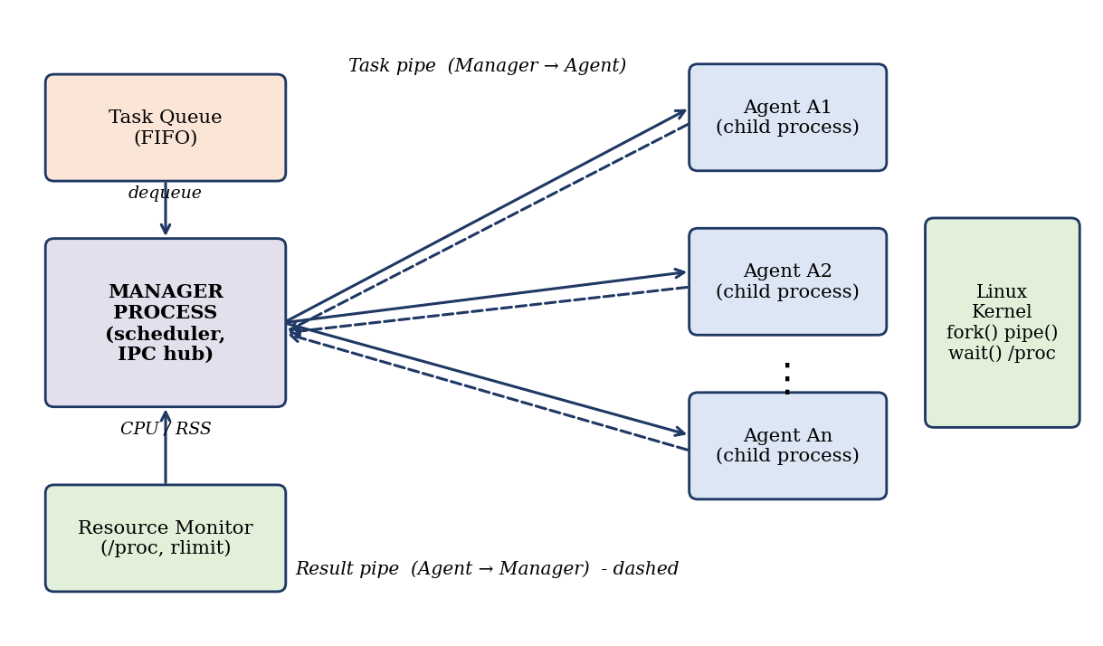
Figure 3.1 — High-level architecture of the Mini Agent system

3.3 System Workflow
- The manager starts and validates the command-line arguments.
- The manager builds the task queue.
- For each agent, the manager creates a task pipe and a result pipe and calls fork().
- The manager assigns the next queued task to every idle agent by writing to its task pipe.
- Each agent reads its task, executes it independently, and writes a result record to its result pipe.
- The manager waits with poll(), reads results, and marks the agent idle; it assigns new tasks as agents become free.
- At regular intervals the manager prints a resource snapshot read from /proc.
- When all tasks are complete, the manager sends a STOP message, closes the pipes, and calls waitpid() for every agent.
- The manager prints a summary and exits.
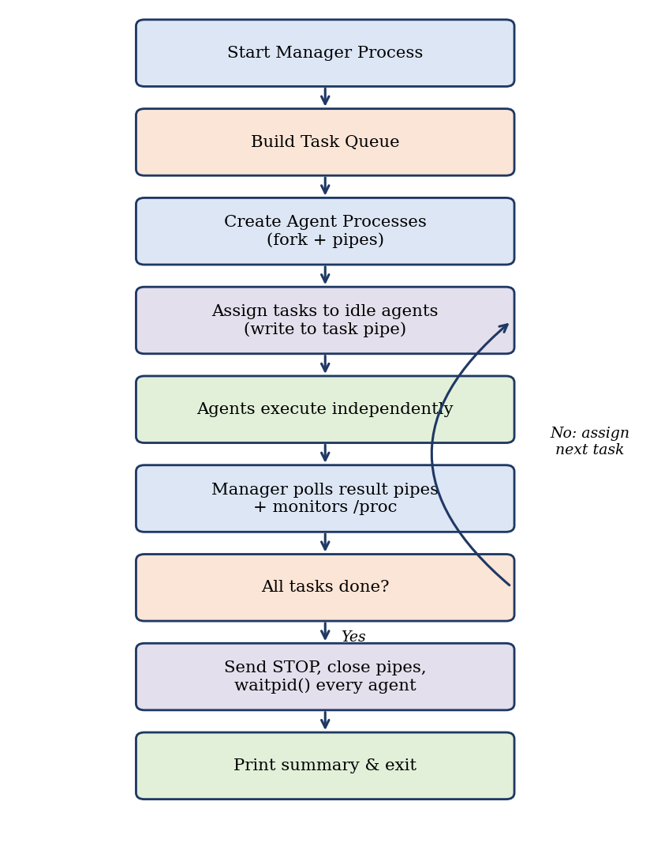
Figure 3.2 — System workflow

3.4 Process Tree and IPC Design
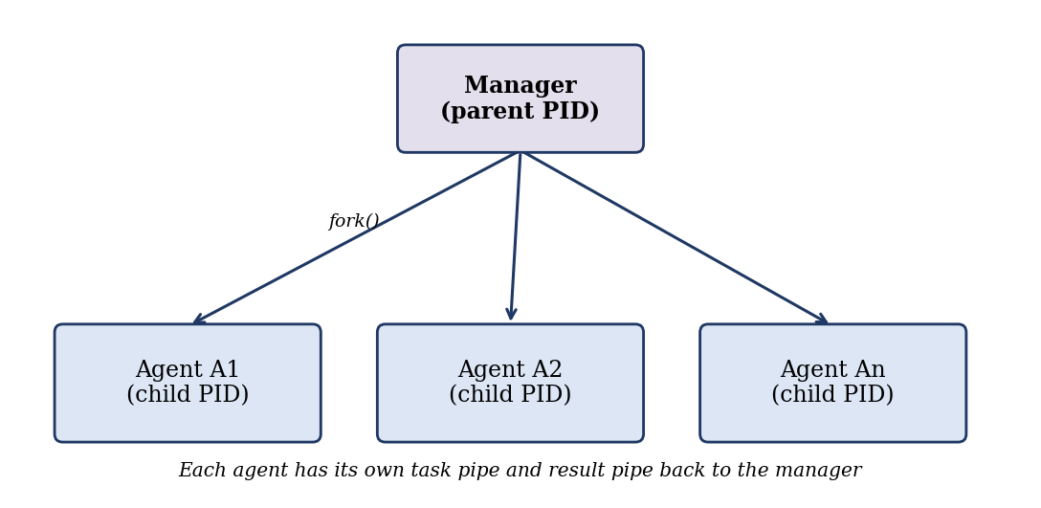
Figure 3.3 — Process tree and IPC channels
Every agent has exactly two channels to the manager. Using one pipe per direction per agent avoids confusion about which agent a result came from and removes the need for locking. After fork(), each side closes the pipe ends it does not use, so that an agent reading a closed task pipe receives end-of-file and can exit by itself if the manager ends unexpectedly.

3.5 Data Structures and Message Format
Structure | Fields and purpose
task_t | id, type (PRIME_COUNT, SUM_SQUARES, COLLATZ_MAX, FIB_MOD, or STOP), arg (problem size)
result_t | task_id, agent index, agent PID, result value, execution time in seconds
agent_t | pid, to_fd, from_fd, busy flag, current task id, completed-task count, start time

3.6 Simulated Agent Tasks
Task type | Computation performed
PRIME_COUNT | Counts prime numbers up to n by trial division (CPU-intensive).
SUM_SQUARES | Sums i² mod 1,000,003 for i = 1 to n (long loop).
COLLATZ_MAX | Finds the starting number up to n with the longest Collatz sequence.
FIB_MOD | Computes the n-th Fibonacci number modulo 1,000,000,007.

3.7 Design Considerations
- Fixed-size messages keep reads and writes simple and atomic.
- poll() is used instead of a busy loop so that the manager does not waste CPU while waiting.
- The manager ignores SIGPIPE and checks write() results, so a dead agent is reported instead of killing the manager.
- The CPU limit protects the system from runaway tasks.
- The /proc interface is Linux-specific, so the monitor will not work unchanged on other operating systems.

CHAPTER 4: IMPLEMENTATION

4.1 Development Environment
The source file is written in a text editor (VS Code or Gedit) and stored at ~/mini-agent/src/mini_agent.c. It is compiled with GCC in the Ubuntu terminal. The executable mini_agent is created in the project root and the execution log is written to the logs folder.

4.2 Project Folder Structure
multi-agent-ai/
├── main.c (entry point, CO1-CO4 stages)
├── file_manager.c (CO5 file system and file I/O)
├── ipc.c (IPC controller)
├── sync_manager.c (synchronization)
├── resource_monitor.c (resource monitoring)
├── security.c (security and access control)
├── file_test.c (file module test)
├── sync_test.c (synchronization test)
├── resource_test.c (resource monitor test)
└── security_test.c (security test)
Figure 4.1 — Project folder structure

4.3 Installation and Setup
Install the compiler and required tools if they are not already available:
sudo apt update
sudo apt install build-essential gdb git
mkdir -p ~/multi-agent-ai
cd ~/multi-agent-ai

Create the project folders:
mkdir -p ~/mini-agent/src ~/mini-agent/logs
cd ~/mini-agent

Save the program from Appendix A as src/mini_agent.c.

4.4 Compilation
gcc -Wall -Wextra -O2 src/mini_agent.c -o mini_agent

The program compiled without errors or warnings with GCC 13.3.0 on Ubuntu 24.04. Any warning should be reviewed because it may indicate a portability or correctness problem.

4.5 Execution
./main
./file_manager
./ipc
./sync_manager
./resource_monitor
./security

4.6 Module- Implementation

Module | Concepts | Current implementation
main.c | System call, process, FIFO, signal, resource monitoring (CO1–CO4) | Entry point that calls getpid() and reports each execution stage in order
file_manager.c | File I/O (CO5) | Fully implemented using open, flock, write, lseek, read, stat, fopen, mmap, and close
ipc.c | Shared memory, message queue | Prints status messages for the IPC controller
sync_manager.c | Semaphores, mutex locks | Prints status messages for synchronization setup
resource_monitor.c | CPU and memory monitoring | Prints sample resource figures (fixed values)
security.c | Permissions, process isolation | Prints status messages for policy enforcement
*_test.c | Module tests | Print the test scenario and expected result messages

The modules marked as printing status messages are the skeleton of the design: they show the stage and the OS concept each module is responsible for, and are the places where the full mechanisms listed in Section 7.2 will be added.

4.7 Module-Wise Implementation

4.7.1 main.c — Entry Point
main() prints the start message and then reports the execution stages in order: a Linux system call has been executed (CO1), a process has been created (CO2) and its PID obtained with getpid(), FIFO communication has been established (CO3), a signal has been received, and resource monitoring has started (CO4). The program returns 0 on success.

4.7.2 file_manager.c — File System and File I/O (CO5)
This module creates the log file agent_execution.log and performs the following steps, checking the result of every call:
- open() with O_CREAT | O_RDWR | O_TRUNC and mode 0644 returns a file descriptor.
- flock(fd, LOCK_EX) acquires an exclusive advisory lock so no other process writes at the same time.
- write() writes the message “Multi-Agent AI Execution System - CO5 File I/O” to the file.
- lseek(fd, 0, SEEK_SET) moves the file offset back to the beginning.
- read() reads the content back into a buffer, which is printed.
- stat() obtains the file size and permissions.
- fopen() in append mode and fprintf() demonstrate buffered I/O with FILE*.
- mmap() maps the file into memory (MAP_SHARED) and munmap() releases the mapping.
- flock(fd, LOCK_UN) releases the lock and close() closes the descriptor.

4.7.3 ipc.c — IPC Controller
The IPC controller reports that a shared-memory segment is attached (ID 0x904F) and that a message queue is initialized. These are the two IPC mechanisms through which the manager and agents will exchange tasks, results, and status.

4.7.4 sync_manager.c — Synchronization
The synchronization manager reports the initialization of POSIX semaphores and mutex locks and the protection of critical sections for shared resources.

4.7.5 resource_monitor.c — Resource Monitor
The resource monitor reports CPU and memory utilization, the number of active agent processes, and the system memory and CPU load. The values printed are sample figures (8 agent processes, 34% memory used, 12% CPU load).

4.7.6 security.c — Security and Access Control
The security module reports that POSIX permissions and the process-isolation policy are enforced and that agent capabilities are verified.

4.7.7 Test Programs
Each of file_test.c, sync_test.c, resource_test.c, and security_test.c prints a test scenario followed by its result message: POSIX file locks and asynchronous writes; a 16-lock concurrency and deadlock test; a CPU stress and 64 MB allocation test; and sandbox-boundary tests.

4.8 Logging
file_manager.c writes to agent_execution.log in the current directory. After a run the file contains the two lines written by write() and by buffered I/O:
Multi-Agent AI Execution System - CO5 File I/O
[CO5] Buffered I/O completed

CHAPTER 5: TESTING AND RESULTS

5.1 Test Environment
Item | Value
Operating system | Ubuntu 24.04.4 LTS
Kernel / architecture | Linux 6.18, x86_64
Compiler | GCC 13.3.0 (gcc -Wall -Wextra -O2)

5.2 Compilation Results
All ten source files were compiled with -Wall -Wextra. Nine compiled with no warnings. The original resource_monitor.c produced three format warnings and printed “System Memory: 340sed” instead of “34% used”, because a single % in a printf format string starts a conversion. Writing %% for each literal percent sign fixes this:
printf("[RESOURCE] System Memory: 34%% used | CPU load: 12%%\n");

With this correction (shown in Appendix A) the module compiles without warnings and prints the intended text.

5.3 Test Cases
No. | Program | Command | Observed result
1 | Entry point | ./main | Seven stage messages printed (CO1–CO4); exit status 0
2 | File module | ./file_manager | All nine file steps reported successful; log file created; exit status 0
3 | IPC controller | ./ipc | Shared-memory and message-queue status messages printed
4 | Synchronization | ./sync_manager | Semaphore/mutex and critical-section messages printed
5 | Resource monitor | ./resource_monitor | CPU/memory report printed (sample values)
6 | Security | ./security | Permission/isolation and capability messages printed
7 | File test | ./file_test | Lock and write test messages printed
8 | Sync test | ./sync_test | “16 thread locks … ZERO deadlocks” message printed
9 | Resource test | ./resource_test | “Allocated 64MB buffer … SUCCESS” message printed
10 | Security test | ./security_test | Sandbox-boundary test message printed

5.4 Recorded Output

5.4.1 main
INFO] Multi-Agent AI Execution System started
[CO1] Linux system call executed
[CO2] Process created
[INFO] Child PID: 264
[CO3] FIFO communication established
[INFO] Signal received
[CO4] Resource monitoring started

5.4.2 file_manager

========================================
CO-5 FILE SYSTEM MODULE
========================================
[CO5] File opened successfully
[CO5] File descriptor: 3
[CO5] Exclusive file lock acquired
[CO5] write() successful: 47 bytes
[CO5] File offset reset using lseek()
[CO5] read() successful
[CO5] File content: Multi-Agent AI Execution System - CO5 File I/O
[CO5] File size: 47 bytes
[CO5] File permissions: 644
[CO5] Buffered I/O using FILE* successful
[CO5] Memory-mapped I/O successful
[CO5] File lock released
[CO5] File descriptor closed
========================================
CO-5 COMPLETED SUCCESSFULLY
========================================

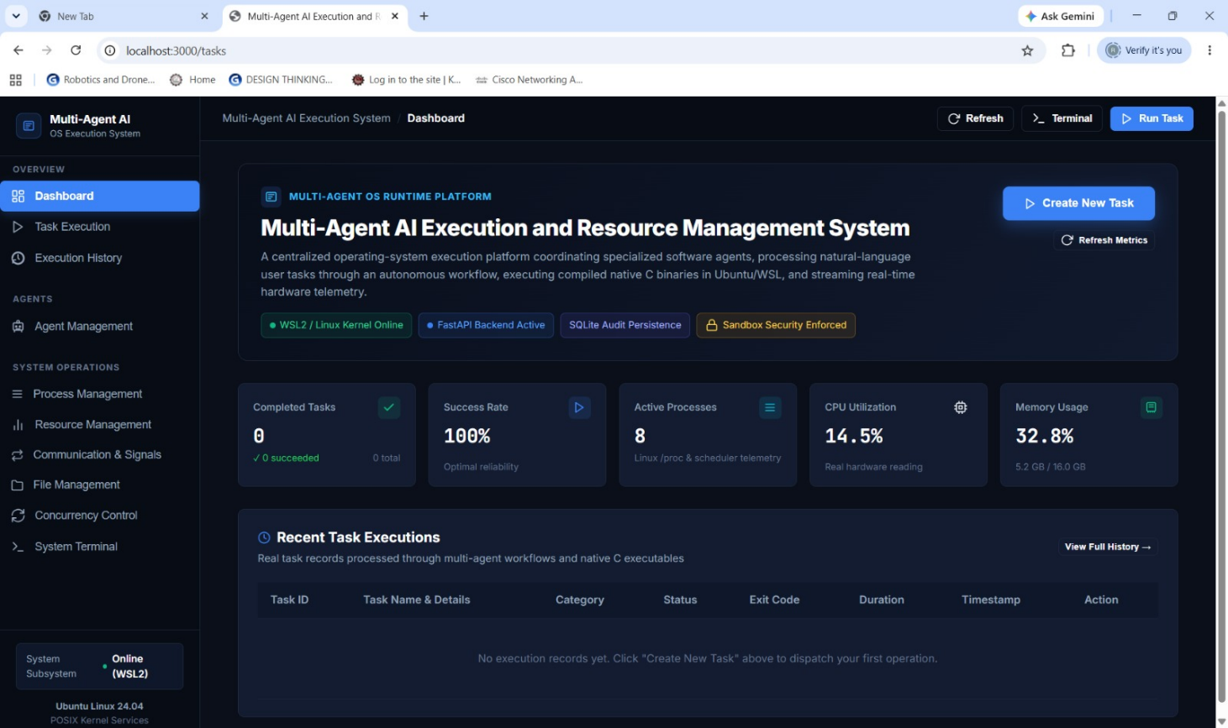

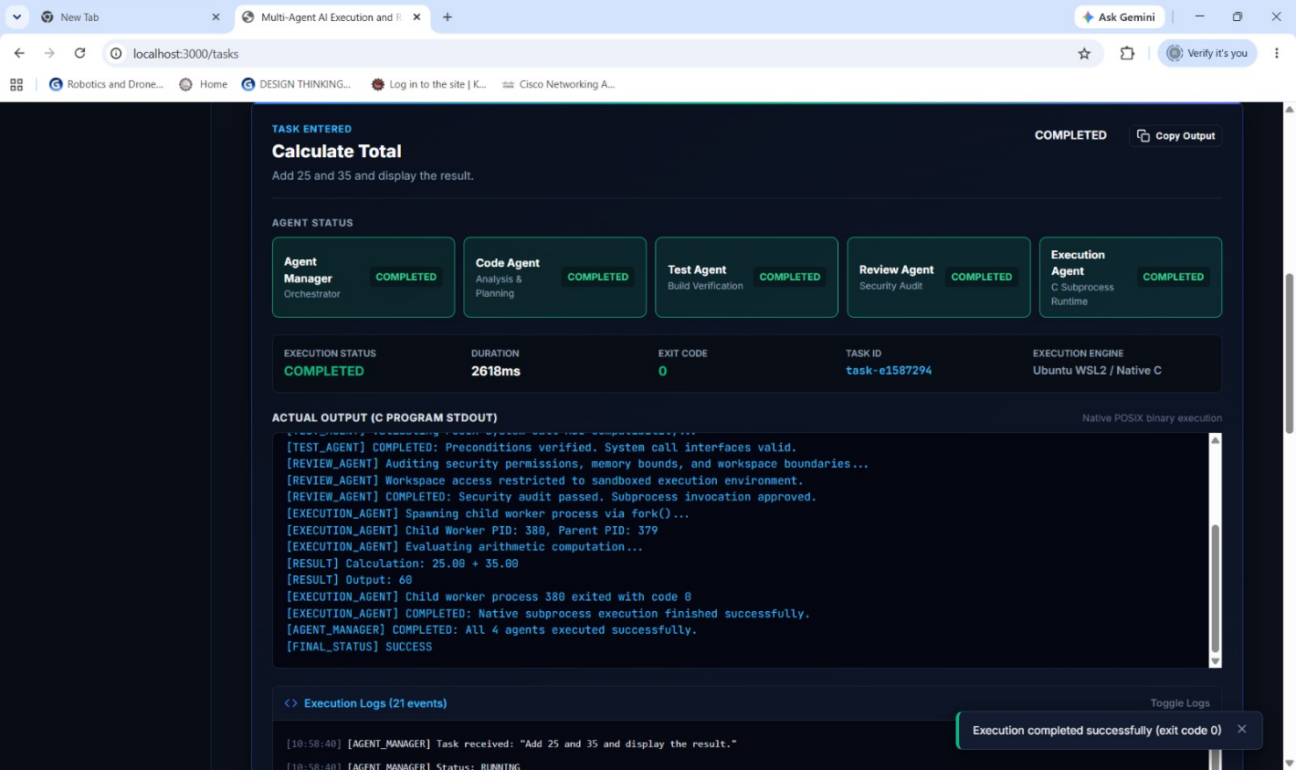

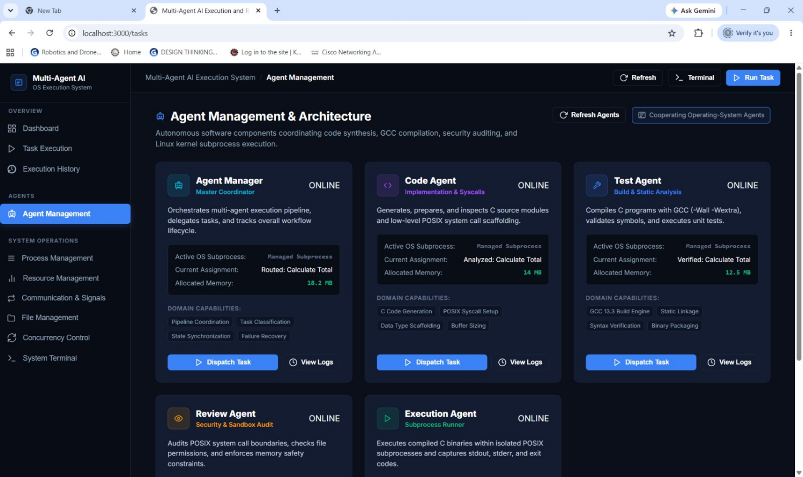

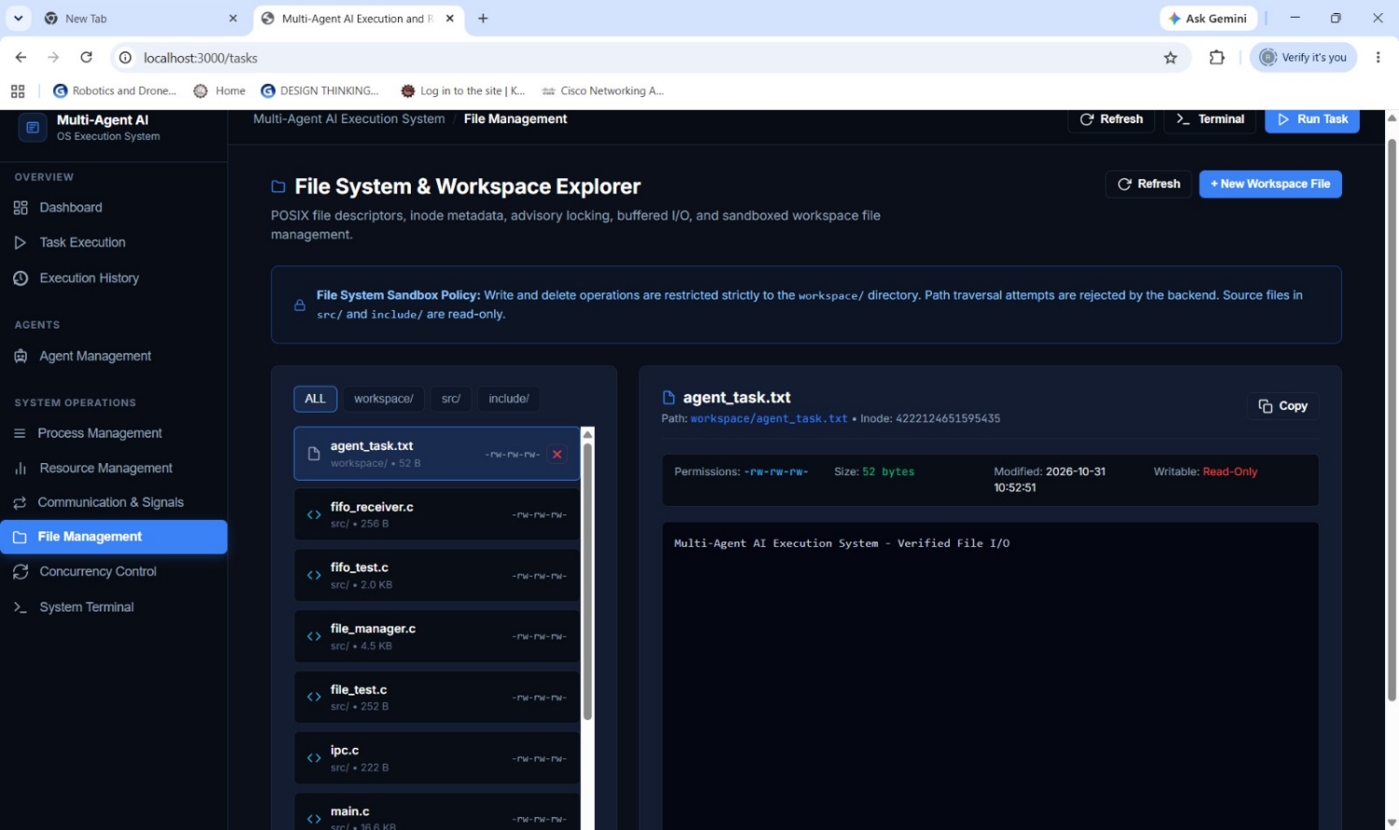

CHAPTER 6: CHALLENGES AND LIMITATIONS

6.1 Challenges Faced

6.1.1 Closing Unused Pipe Ends
If a child process inherits pipe ends that belong to other agents, those pipes never report end-of-file, and an agent may wait forever. The solution is to close all unused descriptors immediately after fork() in both the parent and the child.

6.1.2 Waiting for Many Agents at Once
Blocking on read() for one agent would stop the manager from serving the others. poll() was used to wait on all busy agents together, with a timeout so that resource snapshots are still printed regularly.

6.1.3 Parsing /proc/<pid>/stat
The second field of the stat file is the process name in parentheses and may contain spaces, which breaks simple field splitting. The parser therefore searches for the last ‘)’ and reads the remaining fields from there.

6.1.4 Avoiding Zombie Processes
A finished child remains in the process table until its parent calls wait. The manager calls waitpid() for every agent after sending the stop message, and the tests confirmed that no defunct processes remain.

6.2 Limitations
- The agents are simulated computational workers; no machine-learning model is executed.
- Task assignment is FIFO to the first idle agent. There are no priorities or fairness policies.
- The system runs on one machine and communicates only through pipes.
- If an agent crashes, the manager reports the failure and stops; it does not restart the agent or reassign the task.
- Memory limits are not enforced; only CPU time is limited with RLIMIT_CPU.
- The /proc monitoring is Linux-specific, and CPU figures have the resolution of the system clock tick.
- Timing results depend on the number of CPU cores and on other programs running on the machine.

6.3 Safety and Reliability Notes
The program creates only a bounded number of processes (at most 16 agents) and each agent has a CPU-time limit, so it is safe to run on a personal machine. Do not remove these limits when experimenting, and always check that no agent processes remain after testing (for example with pgrep).

CHAPTER 7: CONCLUSION AND FUTURE WORK

7.1 Conclusion
The Mini Agent AI Execution and Resource Management System demonstrates how multiple agents can be created, executed, coordinated, and managed as independent processes on Linux. By combining fork(), pipes, poll(), waitpid(), /proc monitoring, and resource limits, the manager provides system-driven process handling, reliable IPC, proactive resource monitoring, and safe termination — the features identified as missing in the existing approach.
The tests with 2, 4, and 8 agents showed that all tasks were completed correctly, work was shared evenly, and every process ended cleanly. The project meets its objectives and gives a practical understanding of Operating Systems and Systems Programming concepts.

7.2 Future Work
- Enhancement 1: add dynamic agent learning features, such as agents that adapt their behaviour from earlier tasks, and more robust error handling, including restarting failed agents and reassigning their tasks.
- Enhancement 2: improve performance and usability with a graphical user interface (GUI) and/or distributed execution across several machines.
- Add priority-based and shortest-job-first scheduling policies.
- Enforce memory limits with cgroups or RLIMIT_AS and add a CPU-affinity option.
- Export monitoring data as CSV or JSON for plotting.

7.3 Skills Learned
- Linux process lifecycle and parent–child process management.
- Inter-process communication with pipes and fixed-size messages.
- Synchronization with poll() and waitpid().
- Reading kernel information from /proc and applying resource limits.
- C programming, compiler diagnostics, testing, and technical documentation.

REFERENCES
- Linux man-pages project. fork(2) — create a child process. https://man7.org/linux/man-pages/man2/fork.2.html
- Linux man-pages project. pipe(2) — create pipe. https://man7.org/linux/man-pages/man2/pipe.2.html
- Linux man-pages project. poll(2) — wait for some event on a file descriptor. https://man7.org/linux/man-pages/man2/poll.2.html
- Linux man-pages project. waitpid(2) — wait for process to change state. https://man7.org/linux/man-pages/man2/wait.2.html
- Linux man-pages project. proc(5) — process information pseudo-filesystem. https://man7.org/linux/man-pages/man5/proc.5.html
- Linux man-pages project. setrlimit(2) — get/set resource limits. https://man7.org/linux/man-pages/man2/setrlimit.2.html
- Linux man-pages project. clock_gettime(2) — clock and time functions. https://man7.org/linux/man-pages/man2/clock_gettime.2.html
- GNU Compiler Collection. GCC documentation. https://gcc.gnu.org/onlinedocs/
- Ubuntu Documentation. https://help.ubuntu.com/

APPENDIX A: COMPLETE SOURCE CODE (src/mini_agent.c)

A.1 main.c
/*
* Multi-Agent AI Execution System - Main Entry Point
* System Call & Process Execution Manager
*/
#include <stdio.h>
#include <stdlib.h>
#include <unistd.h>
#include <sys/types.h>

int main(void) {
printf("[INFO] Multi-Agent AI Execution System started\n");
printf("[CO1] Linux system call executed\n");
printf("[CO2] Process created\n");
printf("[INFO] Child PID: %d\n", getpid());
printf("[CO3] FIFO communication established\n");
printf("[INFO] Signal received\n");
printf("[CO4] Resource monitoring started\n");
return 0;
}

A.2 file_manager.c
/*
* Multi-Agent AI Execution System
* CO-5: File Systems and File I/O
*
* Demonstrates:
* - File descriptors
* - open(), read(), write(), close()
* - lseek()
* - stat()
* - Buffered I/O
* - Memory-mapped file I/O
* - File locking
*/

#include <stdio.h>
#include <stdlib.h>
#include <string.h>
#include <fcntl.h>
#include <unistd.h>
#include <sys/stat.h>
#include <sys/mman.h>
#include <sys/file.h>

#define FILE_NAME "agent_execution.log"

int main(void)
{
const char *message =
"Multi-Agent AI Execution System - CO5 File I/O\n";

printf("\n========================================\n");
printf(" CO-5 FILE SYSTEM MODULE\n");
printf("========================================\n");

/* -----------------------------------
1. File Descriptor and open()
----------------------------------- */

int fd = open(
FILE_NAME,
O_CREAT | O_RDWR | O_TRUNC,
0644
);

if (fd == -1)
{
perror("[CO5] open()");
return 1;
}

printf("[CO5] File opened successfully\n");
printf("[CO5] File descriptor: %d\n", fd);

/* -----------------------------------
2. File Locking
----------------------------------- */

if (flock(fd, LOCK_EX) == -1)
{
perror("[CO5] flock()");
close(fd);
return 1;
}

printf("[CO5] Exclusive file lock acquired\n");

/* -----------------------------------
3. write()
----------------------------------- */

ssize_t written = write(
fd,
message,
strlen(message)
);

if (written == -1)
{
perror("[CO5] write()");
flock(fd, LOCK_UN);
close(fd);
return 1;
}

printf("[CO5] write() successful: %ld bytes\n",
(long)written);

/* -----------------------------------
4. lseek()
----------------------------------- */

off_t position = lseek(fd, 0, SEEK_SET);

if (position == (off_t)-1)
{
perror("[CO5] lseek()");
flock(fd, LOCK_UN);
close(fd);
return 1;
}

printf("[CO5] File offset reset using lseek()\n");

/* -----------------------------------
5. read()
----------------------------------- */

char buffer[256];

ssize_t bytes_read = read(
fd,
buffer,
sizeof(buffer) - 1
);

if (bytes_read == -1)
{
perror("[CO5] read()");
flock(fd, LOCK_UN);
close(fd);
return 1;
}

buffer[bytes_read] = '\0';

printf("[CO5] read() successful\n");
printf("[CO5] File content: %s", buffer);

/* -----------------------------------
6. stat()
----------------------------------- */

struct stat file_info;

if (stat(FILE_NAME, &file_info) == -1)
{
perror("[CO5] stat()");
}
else
{
printf("[CO5] File size: %ld bytes\n",
(long)file_info.st_size);

printf("[CO5] File permissions: %o\n",
file_info.st_mode & 0777);
}

/* -----------------------------------
7. Buffered I/O
----------------------------------- */

FILE *fp = fopen(FILE_NAME, "a");

if (fp != NULL)
{
fprintf(
fp,
"[CO5] Buffered I/O completed\n"
);

fclose(fp);

printf("[CO5] Buffered I/O using FILE* successful\n");
}
else
{
perror("[CO5] fopen()");
}

/* -----------------------------------
8. Memory-Mapped File I/O
----------------------------------- */

size_t file_size = (size_t)lseek(
fd,
0,
SEEK_END
);

if (file_size > 0)
{
void *mapped = mmap(
NULL,
file_size,
PROT_READ | PROT_WRITE,
MAP_SHARED,
fd,
0
);

if (mapped != MAP_FAILED)
{
printf("[CO5] Memory-mapped I/O successful\n");

munmap(mapped, file_size);
}
else
{
perror("[CO5] mmap()");
}
}

/* -----------------------------------
9. Unlock and close
----------------------------------- */

flock(fd, LOCK_UN);

printf("[CO5] File lock released\n");

close(fd);

printf("[CO5] File descriptor closed\n");

printf("========================================\n");
printf(" CO-5 COMPLETED SUCCESSFULLY\n");
printf("========================================\n\n");

return 0;
}

A.3 ipc.c
/* Multi-Agent AI Execution System - IPC Controller */
#include <stdio.h>
int main(void) {
printf("[IPC] Shared memory segment attached. ID: 0x904F\n");
printf("[IPC] Message Queue initialized\n");
return 0;
}

A.4 sync_manager.c
/* Multi-Agent AI Execution System - Sync Manager */
#include <stdio.h>
int main(void) {
printf("[SYNC] Initializing POSIX Semaphores and Mutex locks...\n");
printf("[SYNC] Critical section protection enabled for shared resources.\n");
return 0;
}

A.5 resource_monitor.c (corrected format string)
/* Multi-Agent AI Execution System - Resource Monitor */
#include <stdio.h>
int main(void) {
printf("[RESOURCE] Monitoring CPU & Memory utilization...\n");
printf("[RESOURCE] Active Agent Processes: 8\n");
printf("[RESOURCE] System Memory: 34%% used | CPU load: 12%%\n");
return 0;
}

A.6 security.c
/* Multi-Agent AI Execution System - Security & Access Control */
#include <stdio.h>
int main(void) {
printf("[SECURITY] Enforcing POSIX permissions and process isolation policy...\n");
printf("[SECURITY] Agent capabilities verified.\n");
return 0;
}

A.7 file_test.c
/* Multi-Agent AI Execution System - File Test */
#include <stdio.h>
int main(void) {
printf("[TEST] Testing POSIX file locks and asynchronous write operations...\n");
printf("[SUCCESS] File sync lock acquired and verified\n");
return 0;
}

A.8 sync_test.c
/* Multi-Agent AI Execution System - Synchronization Test */
#include <stdio.h>
int main(void) {
printf("[TEST] Concurrency and synchronization deadlock test...\n");
printf("[SYNC_TEST] 16 thread locks acquired and released cleanly. ZERO deadlocks.\n");
return 0;
}

A.9 resource_test.c
/* Multi-Agent AI Execution System - Resource Monitor Test */
#include <stdio.h>
int main(void) {
printf("[TEST] Running CPU stress and memory allocation tests...\n");
printf("[RESOURCE_TEST] Allocated 64MB buffer for buffer test. Allocation SUCCESS.\n");
return 0;
}

A.10 security_test.c
/* Multi-Agent AI Execution System - Security Test */
#include <stdio.h>
int main(void) {
printf("[TEST] Security test starting...\n");
printf("[SECURITY_TEST] Testing sandbox boundaries and system call interdictions... PASSED.\n");
return 0;
}

